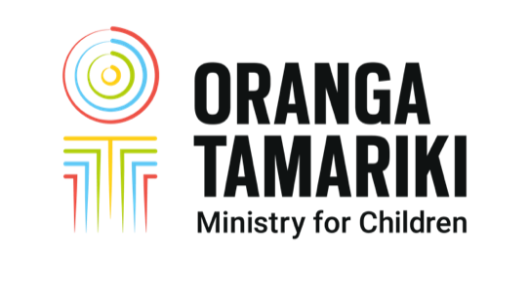

PRIVACY CONSENT

I authorise the Ministry for Children, Oranga Tamariki, (and the responsible minister) to publicly disclose information in response to any information I have given to the media, including any other information that is necessary to respond to questions arising from media coverage.

Name: …………………………………………………………………..

Date of Birth: ……………………………………………………………..

Address:…………………………………………………………………………… …………………………

Phone contacts including mobile: ………………………………………………..

Signature: ………………………………………………………

Recognising that people may find it difficult to sign and return this form in a timely manner, we will accept the consent form without a signature if we are satisfied that it has been sent from the individual’s email address.

Send to reporter or email to media@ot.govt.nz

